About the Samstha & College
Maharshi Karve Stree Shikshan Samstha (MKSSS), Pune, is the 127 years old Samstha committed to “Empowerment & enrichment of Women through Education” and has significantly contributed towards making women professionally educated and self-reliant. Samstha’s Cummins College of Engineering for Women, Nagpur, Maharashtra is empowering the women of Vidarbha in Engineering over a decade for now.
Cummins College of Engineering is NAAC accredited Instiute and was established by the Cummins India Foundation and Maharshi Karave Stree Shikshan Samstha in Nagpur in 2010. It is an accredited institution encouraging creativity and quality in teaching and learning processes for the intellectual growth of its students. The college has three Engineering Departments CE, ETC, & ME. The institute has an excellent placement record with a number of top-ranking companies visiting the campus every year.
About the Conference
The objective of 1st International Conference on “Recent Advances in Science, Engineering & Technology” (ICRASET-2023) is to discuss various points of view, hypotheses, conclusions, and discoveries from students, researchers, technicians, professors, and experts.This conference will serve as a useful tool to raise awareness of the changing changes taking place throughout the spectrum of science, engineering and technology.
Chief Patron
Shri. Jayant Lele
Chairman, MKSSS
Patrons
Mr. PVS Shastri
Secretary, MKSSS
Conference Chairperson
Dr. Milind Khanapurkar,
Principal, Cummins College of Engineering for Women, Nagpur
Convenor
Dr. Sanjivani Shastri, Dean IQAC & Academics
Dr. Mahesh R. Shukla, Dean Metamorphosis & Head ME
Organizing Secretory
Dr. Jitesh Shinde, Dean R&D & Head ETC
Dr. Nikhil Bhave, Assistant Professor, ME
Technical Program Chair
Dr. Jaya Raut, Assistant professor
Dr. Kanchan Wagh, Assistant professor
Dr. Priya Ramteke, Assistant professor
Dr. Asha Gedam, Assistant professor
Dr. Shubhangi Bompaliwar, Assistant professor
Dr. Nikhil Bhave , Assistant professor
Dr. Shailesh Khekale, Assistant professor
Mrs. Supriya Gupta, Assistant professor
Ms. Pinky Gangwani, Assistant professor
Program Publicity Chair
Mrs. Sharayu Deote, Assistant professor
Mr. Harshwardhan Khapate, Assistant professor
Mr. Aditya Kawdaskar, Assistant professor
Mrs. Pallavi Tanksale, Assistant professor
International Conference
On
Recent Advances in Science, Engineering & Technology
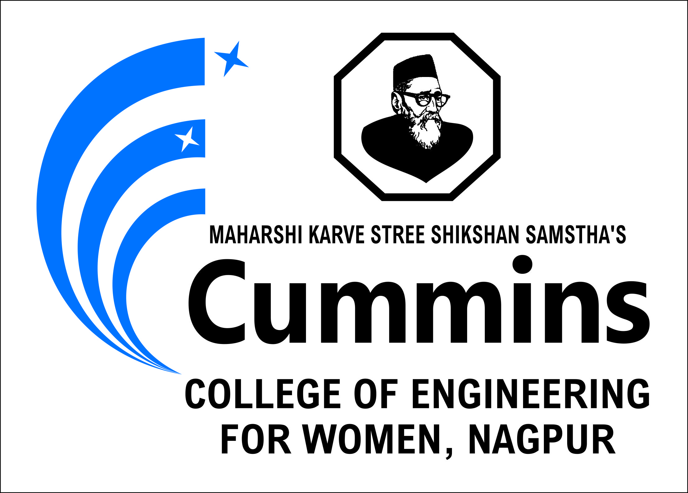
8th & 9th June 2023
Organized by
MKSSS’s Cummins COLLEGE OF ENGINEERING for women, nagpur
Approved by AICTE, New Delhi, Approve by AICTE, Affiliated to Rashtrasant Tukadoji Maharaj Nagpur University,
NAAC Accredited
Hingna Campus, Moje Sukli, (Gupchup), Tal. Hingana, Nagpur, Maharashtra, 441110
www.cumminscollege.edu.in
Our Knowledge Partners
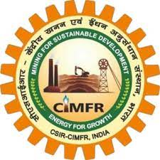
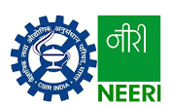

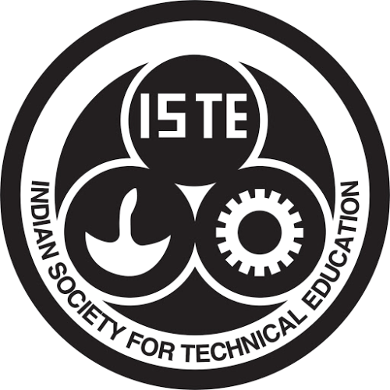
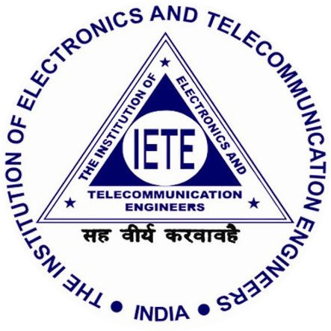
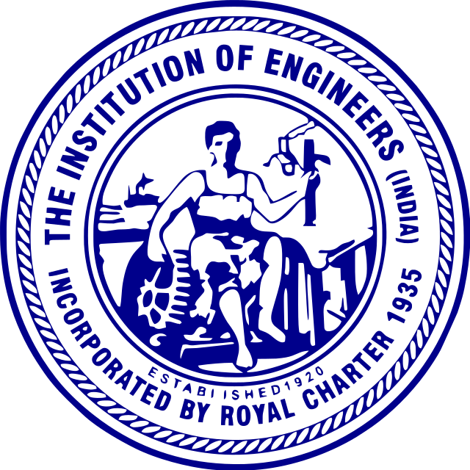
Important Dates
Paper Submission Deadline | 5.7.2023
Notification of Acceptance | 30.07.2023
Camera Ready Submission Deadline | 10.08.2023
Last Date of Registration | 10.08.2023
Conference Date | 24-25 August 2023
International Board Advisory Member
- Dr. Nishu Gupta, Norwegian University of Science and Technology in Gjøvik, Norway
- Mr. Vinod Singh, Alfanar Electric, Suadi Arabia
- Dr. Deepak Kamde, Leeds Univ., UK
- Dr. Naveen Shrivastava, BITS, Dubai
- Mr. Ashutosh Kalinkar, Ford, Mischigan
- Dr. Ranjeet Singh, NewYork Univ., USA
National Board Advisory Member
- Dr. P.N. Padole, Director VNIT, Nagpur
- Dr. Ashish Darpe, IIT Delhi
- Dr. Roshan Patil, IIT Jammu
- Dr. Devendra Sakhare, CSIR-CIMFR
- Dr. Ankit Gupta, CSIR NEERI
- Dr. Ashish Deoghare, NIT Silchar
- Dr. P V Bhale, SVNIT, Surat
- Dr. Ashwin Kumar Dhobale, VNIT Nagpur
- Dr. Tushar Sathe ,VJTI Mumbai
- Dr.Prashant Maheshwary, Chairman BoS, Nagpur University
- Dr. C.C.Handa, Professor, KDKCoE, Nagpur
- Dr. Tushar N. Desai
- Dr. Sanjeev Sharma , Visvesvaraya Technological University
- Dr. Mangesh Nikose, Sandip University
- Dr. Rakesh Nayak, OP Jinadal University
- Dr. M.Krishna Samy, VIT-AP University
- Dr. G.S. Raghtate, Mumbai University
- Dr. Pravin Pokle, RTM Nagpur Univerity
- Mr. Vedant Adhau, Godrej Industry
- Dr. Ramji DR, Tessolve Semiconductor
- Mr. Raj Vardhan, JDM Tech Semiconductor
Scientific Program Committee Member
- Dr. Snehal Chauhan, , Assistant professor
- Mrs. Sneha Uttarwar, , Assistant professor
- Ms. S. Khamankar, Assistant professor
- Ms. Abhilasha Borkar, Assistant professor
- Mr. Yogesh Dandekar, , Assistant professor
- Mr. P. Mahankar, , Assistant professor
- Mr. Sushil Lanjewar, Assistant professor
- Mrs. Saroj Sahoo, Assistant professor
- Mr. Amit Tripathi, , Assistant professor
- Mr. Amit Fulsunge, Assistant professor
Themes of the Conference
Paper are invited in the following themes:
- Mechanical Engineering (Design and Manufacturing Engineering, Materials Science and Engineering, Mechatronics and Automation, Industrial and Systems Engineering, Automobile Engineering, Production Technology, Quality, Six Sigma etc.)
- Computer Engineering (Software Engineering, Computer Applications, & Networks, Algorithms & Data Structure, Cloud Computing, AI-ML etc.)
- Electronics & Communication Engineering (Communication Networks & Security, VLSI, IoT, Signal Processing, Next Generation Networks etc.)
- Basic Science (Mathematical Modelling, Advanced Chemistry, Computational Physics & Biology, Quantum Computation etc.)
- Registration Enquiries
Any query regarding registration may be addressed to
Mr. Harshwardhan Khapate (CE: 9420410225)
Mr. Anand Deshkar (ETC: 9552047776)
Mr. Vikram Dandekar (ME: 9028928806)
Mrs. R. Deshpande (Allied Science.: 9822695556)
International Conference
On
Recent Advances in Science, Engineering & Technology
24th & 25th August 2023
Organized by
MKSSS’s Cummins COLLEGE OF ENGINEERING for women, nagpur
Paper Submission Guidelines
- Full-length original research contributions and review articles in MS word, Times Roman, Font size 12
- The manuscript should contribute original research ideas, developmental ideas, analysis, findings, results, etc.
- The manuscript should not have been published in any journals/magazines or conference proceedings and should not be under review in any of them.
- All accepted papers will be published in indexed conference proceedings.
- Paper should be sent on following email id: raset.confernence@cumminscollege.edu.in
Registration
Author | Registration in INR
Full-time Student / Research Scholar | Rs. 8000/-
Academician | Rs. 10000/-
Industry | Rs. 15000/-
Account Details for Registration
Account Name:
Account Number:
Bank Name:
Branch Name:
IFSC code:
Registration form link:

